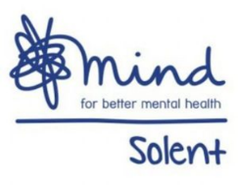

CMA Charity Quiz Night
Wednesday 7th February 2024 at 6:00pm
Concorde Club, Stoneham Lane, Eastleigh, SO50 9HQ
supporting Solent Mind

TEAM REGISTRATION FORM

Company: | Main Contact:
Team Name:
Team Member:  Food Order: | Team Member:  Food Order:
Team Member:  Food Order: | Team Member:  Food Order:
Team Member:  Food Order: | Team Member:  Food Order:

The cost per team is £75 (including food which is to be pre-ordered in advance).
Each team to have a maximum of 6 members.

Menu Choices:
Chicken Curry and Rice
Mushroom Stroganoff and Rice

*Please do let us know of any special dietary requirements so that we can ask the venue to accommodate these requests in advance.

Due to the popularity of the event and in order to secure your team’s place, payment is requested by Friday 27 January 2024.

Please send payment by BACS to:

CMA Financial Recruitment Ltd
HSBC Bank
Sort Code 40 42 18
Account Number 84015827

© Charity Registration No. 1081116

