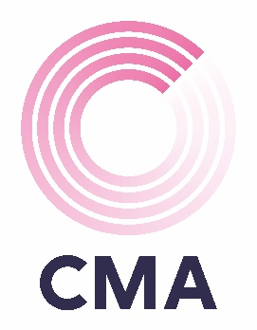

TEAM REGISTRATION FORM

CMA CHARITY QUIZ

Tuesday 5 March 2024

RNLI College West Quay Road Poole BH15 1HZ
6.00pm Arrival

Main contact:
Company:
Number of tickets:

The cost per player is £12.50 (including food) maximum of 6 per team.
If more than 6 tickets are purchased, multiple teams will be allocated.

As you are aware this is a charity event and we would really appreciate a prize donation, big or small, that could be raffled or auctioned. These can be brought with you on the night, or we can arrange to collect them from your place of work.

Food options: Thai Curry | Chilli Con Carne | Rice

Due to the popularity of the event and in order to secure your team’s place, payment is requested by Friday 1st March 2024.

Please make payment via BACS directly to
CMA Financial Recruitment Ltd
Sort code 40-42-18
Account number 84015827
Please quote ref: Bournemouth Quiz Company Name

